Plant Leaf Disease Detection & Classification using CNN

Abstract
Nowadays, for humans, herb plants are important, as well as for the medical field. In this paper, for plant leaf disease detection, we are using four plants, such as chillies, cotton, rice, and tomatoes. For the purpose of analysis in that paper, for the classification of whether the leaf is unhealthy or healthy, Phyllanthus Elegans Wall is used. The function of this plant can cure breast cancer, so we chose it. For breast cancer patients, there is a need for rather alternative methods such as the use of technology in medicine, hospitalisation, surgery, and chemotherapy. In the agriculture field, using technology to identify the quality of leaf from classification, image processing, and image acquisition, for the analysis quality of leaves. For the colour transformation structure using HSV to input RCB image, the most important thing for this part is the segmentation for the method of image processing. On the basis of shape and colour, the analysis of leaf disease images is applied. Finally, as the classification method, employ with a back-propagation algorithm a feed-forward neural network. The result compares Radial Basis Function (RBF) and Multi-layer Perceptron (MLP), with the difference displayed in percentage of accuracy. For neural networks, RBF and MLP are algorithms. We give better accuracy and performance using the classifier of the neural network.

Keywords: Image processing, CNN, Leaf disease, Radial Basis Function , Image Segmentation

CHAPTER 1
INTRODUCTION
In this research, the aim is to develop a technology in agriculture field, based on engineering technique. Nowadays, crops face many traits/diseases. Damage caused by the insect is one of the major trait/disease. Insecticides are not always proven to be efficient because insecticides may be toxic to some kind of birds. It also damages natural animal food chains. A common practice for plant scientists is to estimate the damage of plant (i.e. leaf, stem) based on percentage of the affected area of disease detected by naked eye on a big scale. It results in subjectivity and low throughput. In this paper, for plant leaf disease detection, we are using four plants, such as chillies, cotton, rice, and tomatoes.
This paper provides an advance technique in several methods used to study plant diseases/traits using image processing. The methods studied are for increasing throughput and reducing error arising from human experts in detecting the plant diseases. Detection of leaf disease using engineering technology and mathematically theory in Central Neural Network (CNN) use for analyzes the result. Recently, CNN is widely used in agriculture image processing and it is one of the popular methods for classification problems as compared to most traditional classification approaches. At the end of this study, Neural Network will classify the sample data of leaf image based on healthy or unhealthy category.
Method used for this project is to get leaf image from herb plant. Method of extraction the image acquisition uses suitable image processing algorithms and then makes recognition and classification of healthy or unhealthy leaves using Central Neural Network. Image pattern of classification for this project is based on color and area of leaf. This project relates to the agriculture field based on engineering approaches. The title of this project is leaf disease classification using Central Neural Network. Method for this project is get leaf image from herb plant. Extract the image acquisition using suitable image processing algorithm. Then make recognition and classification of healthy or unhealthy leaves using Central Neural Network. Image pattern of classification for this project is based on color and area of leaf.
Human population steadily continues to grow, and along with it the need for food production increases. According to the UN projections [1], human population is expected to reach 9.7 billion in 2050, 2 billion more than today. Considering that most of the population growth is to occur in the least developed countries (around 80% increase in the next 30 years), where the food scarcity is the main problem, it is easy to conclude that minimizing food loss in those countries is a primary concern.
It is estimated that the yield loss worldwide is between 20 and 40 percent [2], with many farms suffering a total loss. Traditional methods for detecting diseases require manual inspection of plants by experts. This process needs to be continuous, and can be very expensive in large farms, or even completely unavailable to many small farm holders living in rural areas. This is why many attempts to automate disease detection have been made in the last few decades.
One of the notable approaches is the use of hyper spectral imaging. Hyper spectral images are usually taken by satellites or airborne imaging devices and used for monitoring large areas. A downside of this approach is extremely high equipment cost, as well as high dimensionality and small number of samples which make them unsuitable for machine learning (ML) analysis.
Because of the recent breakthroughs in computer vision and the availability of cheap hardware, currently the most popular approach is the analysis of RGB images. The other motive for analysing RGB images is that with the current smartphone iniquitousness these solutions have potential to reach even the most rural areas. RGB images can be analysed by classical ML algorithms or the deep learning (DL) approach.
Classical methods rely on image pre-processing and the extraction of features which are then fed into one of the ML algorithms. Popular algorithm choices are Support Vector Machines (SVM), k-Nearest Neighbours (k-NN), Fully Connected Neural Networks (FCNN), Decision Trees, Random Forests etc. In the last few years, the researchers shifted almost exclusively to the DL methods for image classification tasks.
The reason is that they almost always outperform classical algorithms when given reasonably sized dataset, and can be implemented without the need for hand-engineered features. In this paper, we compare the DL approach with classical ML algorithms for the study case of plant disease classification.

1.1 Machine Learning
1.1.1 Overview
Machine learning is emerging technology day by day in different fields. But now-a-days agriculture is the sector where machine learning applications are in greater demand. Now the question arises what is machine learning? Actually it is nothing but machine that learns from experiences in order to perform specific task. It provides ability to learn. Huge real time data set is provided to the system.
This data set contains set of attributes called as features. Learning uses these features for further analysis. The performance is measured with performance metric. As more data is added over a time, this performance metric is improved with experience. Various mathematical models are used to calculate performance of machine learning algorithm. Machine learning tasks are broadly classified into supervised learning, unsupervised learning, reinforcement learning, Semi-supervised learning and learning models (classification, regression, clustering, and dimensionality reduction). Table 1.1 describes difference between supervised learning and unsupervised learning.
Table 1.1 Difference between supervised learning and unsupervised learning.
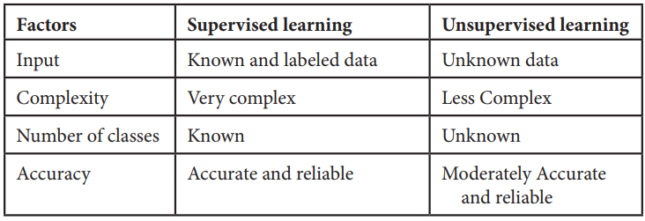
1. Supervised learning:
In supervised learning labelled dataset is used. Here the model is trained on labelled dataset. This dataset contains both input and output parameters. Supervised learning is learning where there is input data, output data and algorithm that maps to input and output. Learning means input and output is provided to machine and machine will develop its own logic for the given task. Some supervised learning algorithms are: Linear Regression, Nearest Neighbour, Gaussian Naive Bayes, Decision Trees, Support Vector Machine (SVM), Random Forest, etc.
The learning is called supervised learning because it is similar to a teacher who is acting as supervisor on entire learning process. The predictions on trained data are generated by learning algorithms. These predictions are corrected by the teacher and learning process is stopped when correct output is achieved [5, 6].
2. Unsupervised learning:
Unsupervised learning is learning that contains only input data and no output data is present. This is applied where there is need to model data distribution in order to get more and more data and there is no any supervisor (like teacher) to supervised the things. Algorithms themselves learn, discover and present structure in data. Here algorithm itself create data pattern. Some recommendation systems for marketing automation use this type of learning.
3. Semi-supervised learning:
The supervised learning has disadvantage that it required labelled dataset. This process is very costly while dealing with large volume of data. Unsupervised learning also has disadvantage that the range of its application is limited. To solve these problems, semi supervised learning algorithms concept was developed. This concept used both labelled data and unlabeled data so that it can work on any type of data. Mostly it contains small amount of labelled data and huge amount of unlabeled data.
1.1.2 Machine Learning Algorithms
There are various machine learning algorithms as described in Figure 1.1 below. These algorithms can be applied in any area to solve various problems.
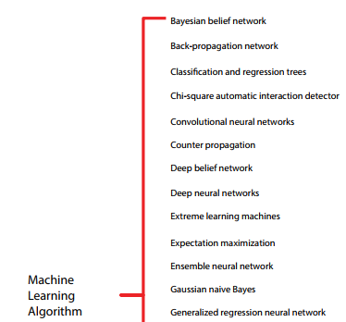
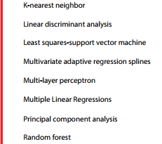
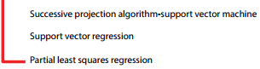
Figure1.1 Machine learning algorithms
1.2.3 Machine Learning Methods
There are various Machine learning methods such as boosting techniques (RGF, GBDT, and Ada boost), Regression Tree (ID3, C4.5), Random Forest, SVM, K Nearest Neighbor, and ANN, etc.
1.2.3.2 CNN
A convolutional neural network (CNN or ConvNet) is a network architecture for deep learning that learns directly from data. CNNs are particularly useful for finding patterns in images to recognize objects, classes, and categories. They can also be quite effective for classifying audio, time-series, and signal data. The pixels from the image are fed to the convolutional layer that performs the convolution operation. It results in a convolved map. The convolved map is applied to a ReLU function to generate a rectified feature map.
The image is processed with multiple convolutions and ReLU layers for locating the features. Convolution is a mathematical operation that allows the merging of two sets of information. In the case of CNN, convolution is applied to the input data to filter the information and produce a feature map. This filter is also called a kernel, or feature detector, and its dimensions can be, for example, 3x3.
A convolutional neural network (CNN or convnet) is a subset of machine learning. It is one of the various types of artificial neural networks which are used for different applications and data types. A CNN is a kind of network architecture for deep learning algorithms and is specifically used for image recognition and tasks that involve the processing of pixel data.
There are other types of neural networks in deep learning, but for identifying and recognizing objects, CNNs are the network architecture of choice. This makes them highly suitable for computer vision (CV) tasks and for applications where object recognition is vital, such as self-driving cars and facial recognition.
Deep learning is a subset of machine learning that uses neural networks with at least three layers. Compared to a network with just one layer, a network with multiple layers can deliver more accurate results. Both RNNs and CNNs are used in deep learning, depending on the application.
For image recognition, image classification and computer vision (CV) applications, CNNs are particularly useful because they provide highly accurate results, especially when a lot of data is involved. The CNN also learns the object's features in successive iterations as the object data moves through the CNN's many layers. This direct (and deep) learning eliminates the need for manual feature extraction (feature engineering).
CNNs can be retrained for new recognition tasks and built on preexisting networks. These advantages open up new opportunities to use CNNs for real-world applications without increasing computational complexities or costs. As seen earlier, CNNs are more computationally efficient than regular NNs since they use parameter sharing. The models are easy to deploy and can run on any device, including smartphones
1.2.3.2 Support Vector Machines
SVM stands for Support Vector Machine. It is a simple algorithm in machine learning. It belongs to the supervised learning category in
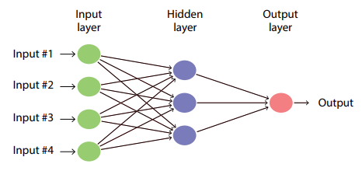
Figure 1.2 Simple Artificial Neural Network
machine learning which is used for both regression and classification analysis but it is a discriminant classifier which is widely used as classification algorithm. It produces significant accuracy with less computation power. This algorithm is used to create a line or a hyper plane in order to separate the data into various classes. It takes the data as input and outputs a line that separates two classes. It is used in variety of applications such as face detection, classification of emails, news articles, web pages, handwriting recognition.
The use of technology in the detection and analysis process increases the accuracy and reliability of these processes. For example, the people who use the latest technology to analyze the diseases that arise unexpectedly are at a higher chance of controlling them than those that do not. In the recent occurrence of coronavirus, the world relied on the latest technology to develop preventive measures that have helped reduce the rate at which the disease is transmitted. Crop diseases are a significant threat to human existence because they are likely to lead to droughts and famines.
They also cause substantial losses in cases where farming is done for commercial purposes. The use of computer vision (CV) and machine learning (ML) could improve the detection and fighting of diseases. Computer vision is a form of artificial intelligence (AI) that involves using computers to understand and identify objects. It is primarily applied in testing drivers, parking, and driving of self-driven vehicles and now in medical processes to detect and analyze objects [1].
Computer vision helps increase the accuracy of disease protection in plants, making it easy to have food security. One of the areas that CV has helped most is the detection of the severity of the diseases. Deep learning (DL), a part of the CV, is useful and promising in determining the severity of diseases in plants and animals [2]. It is also used to classify diseases and avoid the late detection of diseases [1]. Plant diseases are slightly different from those that affect human beings. Many factors make diseases similar as well. However, the diseases that can be transmitted from humans to plants and vice versa are rare.
The analysis of the data related to this field helps identify how the use of the latest technology can be improved. The images of leaves and other parts of the plants can be used to detect diseases in plants [3]. The technology could be applied in analyzing images in human beings that also prove the presence of diseases and determine the extent of their destruction. This research study is aimed at analyzing the way image-based technology can be used in detecting diseases in both plants and animals.
ML is the technology that allows machines to communicate with human beings and understand their needs. It also makes machines act like human beings and make the decision on behalf of humans. It is one of the areas that have grown fast over the past few years. ML helps in classifying plant diseases. The use of this technology is seen as a significant beginning and achievement in dealing with plant diseases. It has also increased productivity in the field of cultivation.
Visualization techniques have also been included in this technology, and it has been improved over the last three years to the current improved levels [4]. The challenges that face the world today, related to the diseases affecting plants and humans, can be reduced if the diseases are identified before they spread to vast areas. The use of ML is widespread in the world today. Diverse methods used in ML and DL help the experts to analyze the plant diseases and know their source in time [4]. The detection of these diseases is affected mainly by several challenges that affect the effectiveness and accuracy of this technology.
The first challenge is the time complexity associated with the use of ML and DL, whereby some of the technologies used in the detection of these diseases are outdated or based on some information from the past. The other challenge is segmentation sensitivity [5]. It means that the region of interest (RoI) requires a high level of accuracy and sensitivity to acquire the required usage and accuracy. The other challenge is that there is a language barrier that affects the way the technology is applied. Another challenge is the inadequate resources that are required to support the application of this technology.
Most of the ML and DL activities need many resources to use and implement. Private and government entities usually fund the institutes that use this technology to detect diseases in humans and plants, which could affect the success of the research and implementation of the technology. The importance of plants in the world has increased over time. The discoveries about the critical roles that plants could play in medicine, energy production, and the recent concerns about the reduction of global warming have for long been a significant part of science and technology [6].
A reduction in the plant cover in the world increases the risk of higher global warming and an increase in the related challenges. The need to build a state-of-the-art convolutional system that supports the image detection technology and classification of plant diseases has led to many research programs to provide the scientists with the required knowledge [7]. Image detection could be applied when necessary to differentiate healthy leaves from those that are not healthy.
The convolutional neural networks (CNNs) provide the differences among plant images that help determine the abnormalities that could exist in the plants in the natural environment [6]. The background study shows that the scanning of the images that show the healthy and unhealthy plants forms a basis for comparison by the scientists in this field. DL can be used to detect abnormalities in both humans and plants. The pixel-wise operations are used to analyze the leaves collected from sick plants, and this is used to classify the diseases according to their impact on the plants.
The visible patterns in these leaves are used to decide the diseases that affect the plants and how they can be dealt with to prevent them from spreading. Research shows that the use of DL technology is up to 98.59% accurate [8]. The field of plant pathology has contributed immensely to the control of diseases and reduced global warming. One of the essential background knowledge that guides the use of image detection technology is that the leaves of the infected plants are different from the healthy ones.
The leaves are likely to have dark parts, and some may be dry along the edges. The dried parts are also likely to fold up, and this is easy to detect even with a bare eye. The use of ML is to detect these differences without human intervention. The ML methods used to make decisions on the detection of diseases include Central Neural Networks (CNN), decision trees, support vector machines (SVM), and K-means, among others [9]. The computers may not work directly with the images taken in the fields.
The images are converted into data that the machines and computers can interpret. It means that the technology requires the coding of the images into data that can be fed into the computer systems. Therefore, the basic knowledge in computer codes and programming forms an integral part of the background knowledge required in this field. Apart from the aforementioned application of the knowledge in plants and detecting the diseases on time, the image-based detection and recognition of diseases are applied in humans to detect the diseases that affect different body parts. Some human diseases have significant impacts on the tissues and organs that they affect.
Adenocarcinoma of the prostate is one of the most common forms of cancer. It is detected using the image-based detection methods whereby the body is scanned for the abnormalities and the images obtained are used to determine if the patient has the disease. It is the second most diagnosed type of cancer in men, with about one in every nine men diagnosed with it in their lifetime [10]. The use of subjective tissue examination has been the primary way of detecting cancer in men suspected of it. The examination of these body tissues is largely dependent on the Gleason system [11].
The field of AI has offered many solutions to the challenge of inaccuracy in the Gleason scale and how it is used to provide solutions to people who have prostate cancer. The AI solutions are applied in analyzing the prostatectomy specimens to determine the impact of cancer on them. Before and after they have been affected by a disease like cancer, the appearance of the body organs is used to design the image-based detection process that is more accurate than the human eyes. In other words, computer systems can detect the difference in the organs more efficiently than humans.
It helps to detect the disease long before they get to a fatal stage. As for some plants like Cassava, it is possible to provide some protection to them from common diseases through image-based detection technology. Agriculture depends on some drought-resistant crops like Cassava to regulate the food supply and ensure an adequate supply of nutrients [12]. However, diseases threaten some of these crops’ survival, which makes it hard for the agriculture departments to meet their targets. The background knowledge about the diseases could help avoid such instances.
The use of CNN generates a reliable platform where the diseases are analyzed in detail [13]. The accuracy of this method is high and reliable. Further research by experts on the diseases that affect plants like Cassava has classified the diseases in terms of their impact on the leaves and other parts of the plants [14]. For example, many diseases affect the part of the leaves, some affect the entire leaf, and others attack the edges or the stalk. The images of the leaves can be analyzed using the image-based detection system to determine the classification that suits the disease.
In places like sub-Saharan Africa, Cassava is one of the essential foods because it provides people with many carbohydrates. However, due to its vulnerability to viral diseases, it has not effectively sustained the nutritional value it could achieve in this region. In 2014, about 145 million tons of Cassava was harvested in Africa [13]. The food control methods applied in the world today mainly focus on increasing production.
The application of the latest technology to detect and control the disease that affects production is a reliable way of reducing the challenges of food inadequacy. Most of the plants are also used as raw materials in many industries. If such plants are of low quality, it means that they will lead to the production of low-standard products.
Fungi usually cause diseases that affect the plants, and they typically attack the leaves. Viral and bacterial pathogens cause many others. Precision in agriculture has improved with the increased use of ML and its related features [15]. The reduced production quantity in agriculture hurts many people and animals, which requires modern technology to solve. The extraction and detection of diseases are easier when the image-based detection system is used because of its high accuracy and reduced complications and duplication of data.
In some plants like tomatoes, the use of the images to determine the diseases that affect them and the extent of the damages cannot be achieved unless there is a high accuracy rate [16]. The survey on plant diseases shows that many diverse factors determine how technology-based image detection is applied. In other words, the diseases that cause visible dents and changes on the plants are the ones that can be detected using this technology as opposed to the ones that cause damages that cannot be detected from the plants’ images [17]. The analysis in this research shows that plant diseases are usually detected when they start showing an impact on the physical appearance of the plants.
The main challenge affecting the field of agriculture is the reduction in production and poor-quality production in plants. The challenge is a result of the poor detection and management of the diseases that affect the plants. The challenge is also extended to affect human beings in several ways. The reduced plant cover due to plant diseases means that global warming, famine, and reduced air purification ensue. Hyper spectral imaging has become a reliable way of detecting crop diseases on time [18].
It is hard to determine the factors that lead to the diseases unless they are detected on time. In other words, if a disease is detected on time, it is easy to relate it to the possible factors that lead to its occurrence. For example, scientists could determine if there was a change in weather or climate that could have led to the occurrence of the disease. Further research by [6] shows an inadequate database that could be used to provide background knowledge for comparing the images taken.
The other challenge is that the symptoms and characteristics of the diseases are diverse and could be similar to a certain degree [19]. For example, many diseases could lead to the wilting of leaves. The challenge is yet to be resolved because more and new images are uploaded progressively by experts. The other challenge is the lack of suitable instruments for use in the work of image detection. Most of the experts in the field do not have the equipment they require to analyze the images they get from the field, and this makes it hard for them to acquire accurate data and identify the diseases [20].
The other one is that there is a low rate of implementation in some areas due to the regulations put in place to ensure the credibility and reliability of the data from these analyses. For example, after the 4th and 6th International Conference on Machine Learning and Soft Computing, there have been many regulations that may derail the use of ML in some parts [21]. The rules discourage some of the results from the ML functions from being applied in practice because they do not meet the required parameters. The technology has been in existence for several years now.
However, there are still many issues that have not been clarified about its application. The other challenge is related to this fact. Some of the important images that could help determine if disease exists have not been captured. The other one is that the future perspectives of the research are not clear, and this is because of the increased diversity in the diseases that affect both humans and animals [19]. The application of image-based detection is also affected by the increased diversity in the way the diseases appear. Some of the diseases that used to affect the plants a few years ago have evolved into new forms, and they have different impacts and outcomes.
It is difficult for the images to be used alone to conclude the diseases and choose a solution. Some of the solutions used in the past have also become ineffective, reducing the effectiveness of the technology. The aforementioned challenges show that there are many possible ways in which the image-based detection could be applied, but the challenges reduce its usability. The first solution is to provide adequate data that can be used to identify the diseases accurately without confusing the ones that are closely related.
The changes in weather, global warming, and other impacts have led to many diseases that have not been documented. The solution is to increase scientists’ coverage and promote a better way of collecting information [22]. The other solution would be to offer training to the scientists in this field to ensure that they are equipped to collect the data. Yet another solution is to create better ways of capturing the data collected about the diseases.
The challenge of inadequate information about the diseases can be solved if there is an improved data-captioning process that involves fine details of the images taken and the differences that define them [6]. The images should be analyzed keenly to determine the ones that are affected or infected.
Another solution would be to focus on using the latest technology that is reliable and valid. The confusion that comes with the inadequate database for use in detecting the diseases results from inferior technology and low storage abilities of the existing systems. Most of the images are not stored correctly, which affects the accessibility of the information. It could be solved by the use of modern methods of storing information. For example, the use of cloud computing could help increase the accuracy of storage and accessibility. The other solution is training the people in charge of the research and analysis of the information.
A trained DL algorithm increases the accuracy of the technology [23]. The other solution would be to understand the phenotypes used in detecting diseases [24]. The phenotype used in the detection of diseases is usually a result of climate and weather [23, 25]. The other solution would be to update the systems to ensure the data captured is up to date. The high level of uncertainty in the detection of diseases affects the way the technology is implemented. For example, the use of Bayesian DL is associated with several uncertainties [26]. It means that this method is unreliable if used alone.
A combination of several methods could reduce the inefficiencies of the processes. For example, the application of DL meta-architectures provides a solution to some of the errors that are experienced when using other methods of identifying diseases [27]. The other solution would be the application of deep convolutional generative adversarial networks that help in the identification and analysis of the images [28]. The contribution of the adversarial networks increases the accuracy of the detection process.
The use of CNN methods could also be effective in dealing with the inaccuracy and slow identification processes of the diseases [29]. The methods have been used to detect the diseases that affect rice and have many benefits [28]. Image-based detection requires many resources, and the authorities should ensure they are available to ensure the activities are smooth.

CHAPTER 2
LITERATURE SURVEY
2.1 Phyllanthus Elegans Wall (Asin-Asin Gajah)
India is an agricultural country wherein most of the population depends on agriculture [1]. And agriculture is one of the major domains which covered economy of the nation. The quality and quantity of the agricultural production is affected by environmental parameters like rain, temperature and other weather parameters which are beyond control of human beings. Another major parameter which affects productivity of the crop is the disease where human beings can have control to improve the productivity for quality as well as for quantity. Farmers in rural country have minimal access to agricultural experts, who can inspect crop images and render advice and farmers have wide range of diversity to select suitable crops for their farm [3].
However, the cultivation of these crops for optimum yield and quality produce is highly technical. It can be improved by the aid of technology support. Generally the naked eye method is used to identify the diseases [4]. In this method experts are involved who have the ability to detect the changes in leaf color. This method involves lots of efforts, takes long time and also not practical for the large fields. Many times different experts identify the same disease as the same disease. This method is expensive as it requires continuous monitoring of experts. The Figure 1 has shown the leaf of Phyllanthus Elegans Wall.
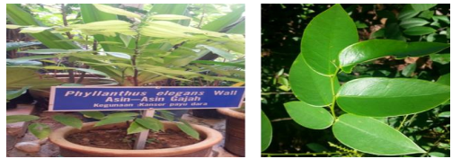
Figure 1 Plant of Phyllanthus Elegans Wall
The expert person for analysis leaf disease can increase cost for agriculture. So, with using technology in agriculture, this method can use for long time and reduce the cost. Plant diseases have turned into a dilemma as it can cause significant reduction in both quality and quantity of agricultural products.
2.2 Image Processing
Method Based on S. Arivazhagan et al. [2] detection and classification of leaf diseases has been proposed. Method for segmentation is based on masking and removing of green pixels, applying a specific threshold to extract the infected region and computing the texture statistics to evaluate the disease. Before segmentation method, S. Arivazhagan et al. [2] using HIS (hue, saturation, intensity) for color transformation structure. HIS color model is a popular color model because it is based on human perception. For texture feature they are using Color-Co-Occurrence.
This method used to develop through the SGDM. From their research, co-occurrence is a statistical way to describe shape by statistically sampling the way certain gray-levels occur in relation to other levels. From the investigation that they have made is classify plant disease into various type [2]. N.J. Janwe and Vinita Tajane [12] suggested for their medical plants disease identification using Canny Edge detection algorithm, Histogram Analysis and CBIR. The identification of medical plants based on its edge features. The leaf image converts to gray scale and calculate the edge histogram.
The algorithm that purposed is canny edge detection. The area and color of the image is extracted in the form of the histogram for the overall image. Based on their research, they find up the color histogram separate the layers of the RGB image into red, green and blue color histogram to check the intensity of each color pixels in that testing which is helpful for identification of healthy and infected sample [12].
2.3 Classification
Many papers have been presented in International Journals and conferences; researchers have worked on hierarchical, neural networks and machine learning methods. The work on classification of leaves started in the early 20th century [13]. Some of the classifier techniques that are always been used by pass researchers are Support Vector Machine (SVM), Neural Network, conventional multiple regression, k-Nearest Neighbor and Genetic Algorithm. Prasad Babu et al. proposed Back propagation neural network for recognition of leaves in [14]. It was proved that just a back propagation network and shape of leaf image is enough to specify the species of a leaf. Tzionas et al. in implemented an artificial vision system that extracted specific geometrical and morphological features [13].
Using a novel feature selection approach, a subset a significant image features was identified. A feed forward neural network was employed to perform the main classification task and that was invariant to size and orientation. It could successfully operate even with the deformed leaves. It achieved a considerable high classification ratio of 99% [13]. Further, Lin and Peng in attempted to realize a computer automatic classification for 30 broad leaved plants in a more convenient, rapid and efficient manner using PNN achieving 98.3% of accuracy [13].
Kumar et al., conducted a survey on different classification techniques; k-Nearest Neighbor classifier, Neural Network, Genetic Algorithm, SVM and Principal Component Analysis and listed their advantages and disadvantages. The drawbacks of SVM are that it is a binary classifier, training is slow, and it is difficult to understand structure of algorithm. It also has limitation with speed and size, both in training and testing [13].
2.4 Method of Back Propagation
Back-propagation algorithm is a systematic method for training a multi-layer perceptron (MLP). The Back propagation algorithm can be used to solve problems in many areas. The back-propagation training algorithm involves 3 stages: i. Feed-forward of the input training pattern ii. Back-propagation of the associated error iii. Weight adjustment A multilayer net can learn the input patterns only to an arbitrary accuracy. A MLP is a multilayer, feed forward neural with an input layer, an output layer and hidden layer.
The neurons in the hidden and the output layers have biases which are similar to weights on connection from units whose output is always 1 [15]. Back-propagation algorithm is derived from generalized delta rule. It is a gradient descendent method which minimizes the total squared error of the output of the network [15]. I. Feed-forward the input training pattern During feed-forward, each input neuron (Xi) receives an input signal and broadcast it to each hidden neuron, which in turn computes the activation and passes it on to each output unit, which again computes the activation to obtain the net output [15]. II. Back-propagation of the associated error During training, the net output is compared with the target value and the appropriate error is calculated.
From the error, the error factor δk is obtained which is used to distribute the error back to the hidden layer. III. Weight adjustment Weight adjustment which means the weight must update when error to distribute the error back to the hidden layer has. In a similar manner, the error factor δj is calculated for unit Zj. After the error factors are obtained, the weights are updated simultaneously.
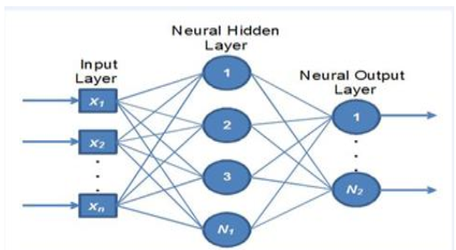
Figure 2 A two layer MLP architecture

CHAPTER 3
LITERATURE SURVEY
[1] United Nations, Department of Economic and Social Affairs, Population Division (2019). World Population Prospects 2019: Highlights (ST/ESA/SER.A/423).
Understanding global population trends and anticipating the demographic changes to come are crucial to the achievement of the 2030 Agenda for Sustainable Development. The 2030 Agenda emphasizes that people are at the centre of sustainable development, echoing the ideals set forth in the Programme of Action of the International Conference on Population and Development adopted in Cairo in 1994.
Population trends observed over the past few decades point to substantial progress made towards several of the Sustainable Development Goals (SDGs) so far. Examples include reduced mortality, particularly among children, as well as increased access to sexual and reproductive health care and enhanced gender equality that have empowered women to decide freely and responsibly the number, spacing and timing of their children.
Recent demographic trends are harbingers of the future challenges to sustainable development. For example, countries experiencing rapid population growth, most of which are in sub-Saharan Africa, must provide schooling and health care to growing numbers of children, and ensure education and employment opportunities to increasing numbers of youth. Countries where population growth has slowed or stopped must prepare for an increasing proportion of older persons and, in some cases, decreasing population size. These and other challenges can be addressed in part by anticipating coming demographic trends and incorporating that information into policies and planning.
The United Nations population estimates and projections form a comprehensive set of demographic data to assess population trends at the global, regional and national levels. They are used in the calculation of many of the key development indicators commonly used by the United Nations system, including for more than one third of the indicators used to monitor progress towards the achievement of the SDGs. The 2019 revision of the World Population Prospects is the twenty-sixth edition of the United Nations population estimates and projections, which have been prepared since 1951 by the Population Division of the Department of Economic and Social Affairs.
The 2019 revision presents population estimates from 1950 until the present for 235 countries or areas, which have been developed through country-specific analyses of historical demographic trends. It builds on previous revisions by incorporating additional results from the 2010 and 2020 rounds of national population censuses as well as information from vital registration and recent nationally representative household surveys. The 2019 revision also presents population projections to the year 2100 that reflect a range of plausible outcomes at the global, regional and country levels.
[2] Savary, Serge, et al. "The global burden of pathogens and pests on major food crops." Nature ecology & evolution 3.3 (2019): 430.
Crop pathogens and pests reduce the yield and quality of agricultural production. They cause substantial economic losses and reduce food security at household, national and global levels. Quantitative, standardized information on crop losses is difficult to compile and compare across crops, agro ecosystems and regions. Here, we report on an expert-based assessment of crop health, and provide numerical estimates of yield losses on an individual pathogen and pest basis for five major crops globally and in food security hotspots. Our results document losses associated with 137 pathogens and pests associated with wheat, rice, maize, potato and soybean worldwide.
Our yield loss (range) estimates at a global level and per hotspot for wheat (21.5% (10.1–28.1%)), rice (30.0% (24.6–40.9%)), maize (22.5% (19.5–41.1%)), potato (17.2% (8.1–21.0%)) and soybean (21.4% (11.0–32.4%)) suggest that the highest losses are associated with food-deficit regions with fast-growing populations, and frequently with emerging or re-emerging pests and diseases. Our assessment highlights differences in impacts among crop pathogens and pests and among food security hotspots. This analysis contributes critical information to prioritize crop health management to improve the sustainability of agro ecosystems in delivering services to societies.
The improvement in the performances of global agricultural and associated food systems includes the consideration of crop pests and pathogens (P&Ps)1–4 . This is because P&Ps are widely recognized as significant obstacles to regular and reliable food systems5. A recent assessment5 documents how crop P&Ps can collectively affect all of the components of food security6, from overall production to physical availability, distribution, economic access, stability of production, quality and nutritive value. P&Ps are not superimposed elements, but instead are integral parts of human-made agro ecosystems. This inherent nature of P&Ps within agro ecosystems in part explains why the accurate quantification of the impacts of P&Ps on the functioning of agro ecosystems is so difficult.
The continuous coevolution between plants and their P&Ps has been extensively studied7–9. This coevolution entails enhanced defense and protection mechanisms to prevent or mitigate injuries on the plant side, and shifting infectivity and aggressiveness (or growth rate and reproduction) on the pathogen, or pest, side In the case of cultivated plants, the plant–P&P coevolution process is first driven by the fact that cultivated crop stands most generally consist in cohorts of plant individuals that are at the same physiological and phonological stage10, where adapted P&P genotypes may rapidly reproduce.
Furthermore, the shift from small scale, diverse, single-cycle agriculture (generally associated with traditional farming) to large-scale, genetically uniform, intensive monoculture production (associated with some current farming systems) has been considered as a disruption of co-evolutionary processes, which favors strong, large-scale outbreaks and epidemics9 in agro ecosystems that have been rendered more vulnerable10,11 to P&Ps. Uniform, indiscriminate implementation of P&P management instruments, such as host plant resistance genes or chemical pesticides, is also a source for instability and outbreaks.
[3] Mohanty, Sharada P., David P. Hughes, and Marcel Salathé. "Using deep learning for image-based plant disease detection." Frontiers in plant science 7 (2016): 1419.
Crop diseases are a major threat to food security, but their rapid identification remains difficult in many parts of the world due to the lack of the necessary infrastructure. The combination of increasing global smartphone penetration and recent advances in computer vision made possible by deep learning has paved the way for smartphone-assisted disease diagnosis. Using a public dataset of 54,306 images of diseased and healthy plant leaves collected under controlled conditions, we train a deep convolutional neural network to identify 14 crop species and 26 diseases (or absence thereof).
The trained model achieves an accuracy of 99.35% on a held-out test set, demonstrating the feasibility of this approach. Overall, the approach of training deep learning models on increasingly large and publicly available image datasets presents a clear path toward smartphone-assisted crop disease diagnosis on a massive global scale.
Modern technologies have given human society the ability to produce enough food to meet the demand of more than 7 billion people. However, food security remains threatened by a number of factors including climate change (Tai et al., 2014), the decline in pollinators (Report of the Plenary of the Intergovernmental Science-Policy Platform on Biodiversity Ecosystem and Services on the work of its fourth session, 2016), plant diseases (Strange and Scott, 2005), and others.
Plant diseases are not only a threat to food security at the global scale, but can also have disastrous consequences for smallholder farmers whose livelihoods depend on healthy crops. In the developing world, more than 80 percent of the agricultural production is generated by smallholder farmers (UNEP, 2013), and reports of yield loss of more than 50% due to pests and diseases are common (Harvey et al., 2014). Furthermore, the largest fraction of hungry people (50%) live in smallholder farming households (Sanchez and Swaminathan, 2005), making smallholder farmers a group that’s particularly vulnerable to pathogen-derived disruptions in food supply.
Various efforts have been developed to prevent crop loss due to diseases. Historical approaches of widespread application of pesticides have in the past decade increasingly been supplemented by integrated pest management (IPM) approaches (Ehler, 2006). Independent of the approach, identifying a disease correctly when it first appears is a crucial step for efficient disease management.
[4] Fujita, E., et al. "A practical plant diagnosis system for field leaf images and feature visualization." International Journal of Engineering & Technology 7.4.11 (2018): 49-54.
An accurate, fast and low-cost automated plant diagnosis system has been called for. While several studies utilizing machine learning techniques have been conducted, significant issues remain in most cases where the dataset is not composed of field images and often includes a substantial number of inappropriate labels. In this paper, we propose a practical automated plant diagnosis system.
We first build a highly reliable dataset by cultivating plants in a strictly controlled setting. We then develop a robust classifier capable of analyzing a wide variety of field images. We use a total of 9,000 original cucumber field leaf images to identify seven typical viral diseases, Downy mildew and healthy plants including initial symptoms. We also visualize the key regions of diagnostic evidence. Our system attains 93.6% average accuracy, and we confirm that our system captures important features for the diagnosis of Downy mildew.
Plant diseases affect agricultural production all over the world [1- 3]. To minimize the damage and avoid secondary infection, we have to identify the infected plants and apply an appropriate treatment as soon as possible (e.g., removal of infected plants or pesticide application). Plant diagnosis is generally conducted through visual examination by experts with subsequent genetic testing applied as necessary, thus it is usually expensive and time consuming. In such circumstances, methodologies for automated plant diagnosis characterized by accuracy, speed and low costs have been requested by the agricultural industry. Several studies have been carried out in response to such requests [4-23].
In [4] used support vector machines (SVM) to classify rice plant diseases and attained 92.7% accuracy. In [5] analysed leaf and stem images of plants with an artificial neural network classifier. Their classifier achieved around 93% accuracy in classifying them into six classes (five diseases and a healthy state). In [7] also used an artificial neural network classifier and showed 87.8% in fungal disease diagnosis. In [12] discriminated cassava diseases in five categories (four diseases and a healthy state) and estimated their severity in five grades from healthy (= 1) to terminal (= 5). They used a combination of their original feature descriptors and classifiers such as linear SVM.
They claimed 99.98% and nearly 99% accuracy in disease severity estimation and classification, respectively. In [18] investigated six kinds of Cercospora leaf spots of sugar cane with an evaluation of common statistical and handmade image features. Their method attained 82% accuracy. These methods successfully established preferable performance for their own target task. However, since they are designed based on conventional pattern recognition techniques, i.e. a sequential process of (1) preprocessing including segmentation, detection of the regions of interests (ROI), etc., (2) development of hand-crafted features specially designed for a specific task and (3) classification. Thus, they usually have constraints on their usage.
[5] Haralick, Robert M., Karthikeyan Shanmugam, and Its' Hak Dinstein. "Textural features for image classification." IEEE Transactions on systems, man, and cybernetics 6 (1973): 610-621.
Texture is one of the important characteristics used in identifying objects or regions of interest in an image, whether the image be a photomicrograph, an aerial photograph, or a satellite image. This paper describes some easily computable textural features based on gray-tone spatial dependencies, and illustrates their application in category-identification tasks of three different kinds of image data: photomicrographs of five kinds of sandstones, 1:20 000 panchromatic aerial photographs of eight land-use categories, and Earth Resources Technology Satellite (ERTS) multispecial imagery containing seven land-use categories.
We use two kinds of decision rules: one for which the decision regions are convex polyhedra (a piecewise linear decision rule), and one for which the decision regions are rectangular parallelpipeds (a min-max decision rule). In each experiment the data set was divided into two parts, a training set and a test set. Test set identification accuracy is 89 percent for the photomicrographs, 82 percent for the aerial photographic imagery, and 83 percent for the satellite imagery. These results indicate that the easily computable textural features probably have a general applicability for a wide variety of image-classification applications.
WITH THE ADVENT of high-speed general-purpose digital computers it is becoming possible to perform mathematical or algorithmic processes on pictorial data from images of photographic quality. In most of these processes, the pictorial information is represented as a function of two variables (x,y). The image in its digital form is usually stored in the computer as a two-dimensional array. If Lx = {1,2, ,N,} and Ly = {1,2, * ,NY} are the X and Y spatial domains, then LX x Ly is the set of resolution cells and the digital image I is a function which assigns some gray-tone value G E { 1,2, ,NJ to each and every resolution cell; I: Lx x Ly- G. Various two-dimensional analyses are performed on I to achieve specific image processing tasks such as coding, restoration, enhancement, and classification. In recent years a tremendous amount of computer processing of photographs has occurred, with facilities having been developed to process anything from aerial photographs to photomicrographs.
[6] Cortes, Corinna, and Vladimir Vapnik. "Support-vector networks." Machine learning 20.3 (1995): 273-297.
The support-vector network is a new learning machine for two-group classification problems. The machine conceptually implements the following idea: input vectors are non-linearly mapped to a very high dimension feature space. In this feature space a linear decision surface is constructed. A special property of the decision surface ensures high generalization ability of the learning machine.
The idea behind the support-vector network was previously implemented for the restricted case where the training data can be separated without errors. We here extend this result to non-separable training data. High generalization ability of support-vector networks utilizing polynomial input transformations is demonstrated. We also compare the performance of the support-vector network to various classical learning algorithms that all took part in a benchmark study of Optical Character Recognition.
This paper introduces the support-vector network as a new learning machine for two-group classification problems. The support-vector network combines 3 ideas: the solution technique from optimal hyperplanes (that allows for an expansion of the solution vector on support vectors), the idea of convolution of the dot-product (that extends the solution surfaces from linear to non-linear), and the notion of soft margins (to allow for errors on the training set).
The algorithm has been tested and compared to the performance of other classical algorithms. Despite the simplicity of the design in its decision surface the new algorithm exhibits a very fine performance in the comparison study. Other characteristics like capacity control and ease of changing the implemented decision surface render the support-vector network an extremely powerful and universal learning machine.
[7] Cunningham, Padraig, and Sarah Jane Delany. "K-Nearest neighbor classifiers." Multiple Classifier Systems 34.8 (2007): 1- 17.
K-Nearest Neighbours is one of the simplest Machine Learning algorithms based on Supervised Learning technique. K-NN algorithm assumes the similarity between the new case/data and available cases and put the new case into the category that is most similar to the available categories. K-NN algorithm stores all the available data and classifies a new data point based on the similarity. This means when new data appears then it can be easily classified into a well suite category by using K- NN algorithm. K-NN algorithm can be used for Regression as well as for Classification but mostly it is used for the Classification problems.
K-NN is a non-parametric algorithm, which means it does not make any assumption on underlying data. It is also called a lazy learner algorithm because it does not learn from the training set immediately instead it stores the dataset and at the time of classification, it performs an action on the dataset. KNN algorithm at the training phase just stores the dataset and when it gets new data, and then it classifies that data into a category that is much similar to the new data.
Why do we need a K-NN Algorithm?
Suppose there are two categories, i.e., Category A and Category B, and we have a new data point x1, so this data point will lie in which of these categories. To solve this type of problem, we need a K-NN algorithm. With the help of K-NN, we can easily identify the category or class of a particular dataset. Consider the below diagram:
How does K-NN work?
The K-NN working can be explained on the basis of the below algorithm: Step-1: Select the number K of the neighbors Step-2: Calculate the Euclidean distance of K number of neighbors Step-3: Take the K nearest neighbors as per the calculated Euclidean distance. Step-4: Among these k neighbors, count the number of the data points in each category. Step-5: Assign the new data points to that category for which the number of the neighbor is maximum. Step-6: Our model is ready.
There is no particular way to determine the best value for "K", so we need to try some values to find the best out of them. The most preferred value for K is 5. A very low value for K such as K=1 or K=2, can be noisy and lead to the effects of outliers in the model. Large values for K are good, but it may find some difficulties.
Advantages of KNN Algorithm: It is simple to implement. It is robust to the noisy training data it can be more effective if the training data is large.
Disadvantages of KNN Algorithm: Always needs to determine the value of K which may be complex some time. The computation cost is high because of calculating the distance between the data points for all the training samples.
[9] Szegedy, Christian, et al. "Going deeper with convolutions." Proceedings of the IEEE conference on computer vision and pattern recognition. 2015.
We propose a deep convolutional neural network architecture codenamed Inception that achieves the new state of the art for classification and detection in the ImageNet Large-Scale Visual Recognition Challenge 2014 (ILSVRC14). The main hallmark of this architecture is the improved utilization of the computing resources inside the network. By a carefully crafted design, we increased the depth and width of the network while keeping the computational budget constant.
To optimize quality, the architectural decisions were based on the Hebbian principle and the intuition of multi-scale processing. One particular incarnation used in our submission for ILSVRC14 is called GoogLeNet, a 22 layers deep network, the quality of which is assessed in the context of classification and detection.
In the last three years, our object classification and detection capabilities have dramatically improved due to advances in deep learning and convolutional networks [10]. One encouraging news is that most of this progress is not just the result of more powerful hardware, larger datasets and bigger models, but mainly a consequence of new ideas, algorithms and improved network architectures. No new data sources were used, for example, by the top entries in the ILSVRC 2014 competition besides the classification dataset of the same competition for detection purposes.
Our GoogLeNet submission to ILSVRC 2014 actually uses 12 times fewer parameters than the winning architecture of Krizhevsky et al [9] from two years ago, while being significantly more accurate. On the object detection front, the biggest gains have not come from naive application of bigger and bigger deep networks, but from the synergy of deep architectures and classical computer vision, like the R-CNN algorithm by Girshick et al.
Our results yield a solid evidence that approximating the expected optimal sparse structure by readily available dense building blocks is a viable method for improving neural networks for computer vision. The main advantage of this method is a significant quality gain at a modest increase of computational requirements compared to shallower and narrower architectures.
[10] Duan, Kai-Bo, and S. Sathiya Keerthi. "Which is the best multiclass SVM method? An empirical study." International workshop on multiple classifier systems. Springer, Berlin, Heidelberg, 2005.
Binary (two-class) classification using support vector machines (SVMs) is a very well developed technique [1] [11]. Due to various complexities, a direct solution of multiclass problems using a single SVM formulation is usually avoided. The better approach is to use a combination of several binary SVM classifiers to solve a given multiclass problem. Popular methods for doing this are: one-versus-all method using winner-takes-all strategy (WTA SVM); one-versus one method implemented by max-wins voting (MWV SVM); DAGSVM [8]; and error-correcting codes [2].
Hastie and Tibshirani [4] proposed a good general strategy called pairwise coupling for combining posterior probabilities provided by individual binary classifiers in order to do multiclass classification. Since SVMs do not naturally give out posterior probabilities, they suggested a particular way of generating these probabilities from the binary SVM outputs and then used these probabilities together with pairwise coupling to do multiclass classification.
Hastie and Tibshirani did a quick empirical evaluation of this method against MWV SVM and found that the two methods give comparable generalization performances Platt [7] criticized Hastie and Tibshirani’s method of generating posterior class probabilities for a binary SVM, and suggested the use of a properly designed sigmoid applied to the SVM output to form these probabilities.
However, the use of Platt’s probabilities in combination with Hastie and Tibshirani’s idea of pairwise coupling has not been carefully investigated thus far in the literature. The main aim of this paper is to fill this gap. We did an empirical study and were surprised to find that this method (we call it as PWC PSVM) shows a clearly superior generalization performance over MWV SVM and WTA SVM; the superiority is particularly striking when the training dataset is sparse.
We also considered the use of binary kernel logistic regression classifiers1 together with pairwise coupling. We found that even this method is somewhat inferior to PWC PSVM, which clearly indicates the goodness of Platt’s probabilities for SVMs. The results of this paper indicate that PWC PSVM is the best single kernel discriminant method for solving multiclass problems.

CHAPTER 4
EXISTING METHOD
Agriculture is an important source in the economic development of India. About 70% of Indian economy relies on agriculture. Hence, damage to the crops would lead to huge loss in productivity and would ultimately affect the economy. Leaves being the most sensitive part of plants show disease symptoms at the earliest [1]. The crops need to be monitored against diseases from the very first stage of their life-cycle to the time they are ready to be harvested. Initially, the method used to monitor the plants from diseases was the traditional naked eye observation that is a time-consuming technique which requires experts to manually monitor the crop fields [2].
In the recent years, a number of techniques have been applied to develop automatic and semi-automatic plant disease detection systems. These systems have so far resulted to be fast, inexpensive and more accurate than the traditional method of manual observation by farmers [3]. Thus, this invokes researchers to deploy more intelligent technological systems for plant disease detection which do not require human intervention.
D.A. Bashish, et.al (2010) opted for k-means segmentation for partitioning the leaf image into four clusters using the squared Euclidean distances. The method applied for feature extraction is Color Co-occurrence method for both color and texture features [4]. Finally, classification is completed using neural network detection algorithm based on Back Propagation methodology. The overall system disease detection and classification accuracy was found to be around 93%.
M.Bhange et.al (2015) A web-based tool has been developed to identify fruit diseases by uploading fruit image to the system [5]. Features extraction has been done using parameters such as color, morphology ans CCV (color coherence vector). Clustering has been done using the kmeans algorithm. SVM is used for classification as infected or non-infected. This work achieved an accuracy of 82% to identify pomegranate disease.
J.D. Pujari et.al (2015) has taken a number of crop types namely, fruit crops, vegetable crops, cereal crops and commercial crops to detect fungal diseases on plant leaves. Different methods have been adopted for each type of crop [6].
Many existing machine learning classifiers fails for leaf disease detection such as SVM , KNN, Decision Tree , Random Forest, etc. the above mentioned classifiers gives lower accuracy than proposed ANN.

CHAPTER 5
PROPOSED METHOD
This chapter describe about process to get the result of the classification of leaf disease. Figure 3 shows the flow chart of the proposed approach. First process is getting the image acquisition by using 8-Mega Pixel smart phone. The fifty samples image for healthy leaf image and fifty sample unhealthy leaf images are taken and the image processing method is used. The process for image processing has three components which are contrast enhancement, segmentation and features extraction. Lastly, the collected data will be classified to health or unhealthy of leaves using Central Neural Network.
Run DNN algorithm
Upload Plant dataset
Extract Texture and GLCM Feature
Comparison Graph
Run SVM algorithm
Run CNNN algorithm
Disease detection and recommend Fertilizer from text image

Figure 3 The flow chart of the proposed system
To classify and detect the disease of the leaf we are using CNN algorithm in this project. To train our algorithm we used the 'Plant Village' dataset, which covers 25 distinct forms of leaf disorders, including health leaf.
Proposed Algorithm: (CNN algorithm is used for leaf disease)
We have designed a module to implement this project:
- Upload Leaf Disease Dataset: We will upload leaf dataset using this module to application.
- Image Pre-processing: We will read all the images using this module and equal to size it resize the images and all pixel values then normalize.
- Segmentation & Features Extraction: To segment infected part we will apply KMEANS algorithm using this module of the leaf and then apply the algorithm of PCA feature extraction.
- Train CNN algorithm: To train a model extracted features will be input to algorithm CNN and to classify and detect disease this model can be applied on test images.
- Disease Classification: We will upload using this module test images and after that to detect disease CNN model from that image.
SYSTEM ARCHITECTURE
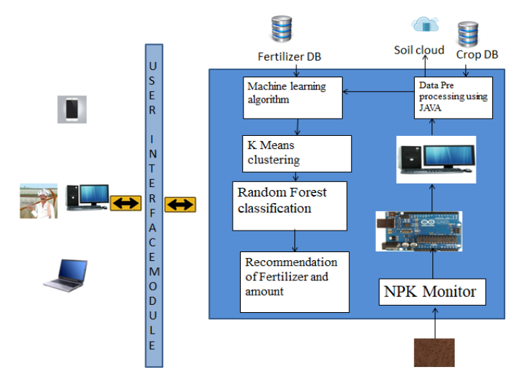
Figure : System Architecture
CHAPTER 6
IMPLEMENTATION

6.1 Explanation of Key Elements

6.1.1 PYTHON

Guido Van Rossum designed Python, an interpreted, high-level, general-purpose programming language that was initially released in 1991.

The Python language has the following features:

• Simple to Understand and Apply Python is a simple language to learn and use. It's a high-level programming language that's helpful to developers.

• Expressive Language Python is more expressive than other languages, making it more intelligible and readable.

• Language Interpretation Python is an interpreted language, which means that the interpreter runs the code line by line. This makes debugging simple, making it suitable for novices.

• Language that is cross-platform Python can operate on a variety of platforms, including Windows, Linux, UNIX, and Macintosh, among others. As a result, we may conclude that Python is a portable language.

• Open Source and Free Software Python is a free programming language that can be downloaded from a secure internet address. It's also possible to get the source code. As a result, there is an open supply.

• Object-Oriented Programming Python aids the development of object-oriented languages and concepts such as classes and gadgets.

• Adaptable It means that other languages, such as C/C++, may be used to put the code together, and as a result, it can be utilized in our Python code.

6.2 Library Files
6.2.1 NUMPY:

NumPy is a Python library that includes support for enormous, multi-dimensional arrays and matrices, as well as a large set of high-level mathematical functions that may be applied to those arrays. Numeric, the forerunner to NumPy, was designed by Jim Hugunin with help from a number of other people. Travis Oliphant built NumPy in 2005 by heavily modifying Numeric and combining features from the competitor Numarray. NumPy is a large open-source software project with numerous contributors.

The Python programming language was not initially intended for numerical computing, but it quickly caught the attention of the clinical and engineering communities, prompting the formation of a special interest group known as matrix-sig in 1995 with the goal of defining an array computing bundle. Guido van Rossum, a Python clothier and maintainer, was one of its contributors, adding changes to Python's grammar (especially the indexing syntax) to make array computation easier.

Jim Fulton completes a matrix package, which is later modified by Jim Hugunin to create Numeric, also known as Numerical Python extensions or NumPy. Hugunin, a PhD student at MIT, joined the Corporation for National Research Initiatives (CNRI) to work on JPython in 1997, leaving the maintainer position to Paul Dubois of Lawrence Livermore National Laboratory (LLNL). David Ascher, Konrad Hinsen, and Travis Oliphant were among the early members.

NumPy is a non-optimizing byte code interpreter that targets the CPython Python reference implementation. Algorithms created for this version of Python are frequently much slower than their compiled counterparts.

NumPy tackles the slowness issue in part by providing multidimensional arrays and capabilities and operators that work appropriately on arrays, which necessitates rewriting some code, generally inner loops, in order to use NumPy. NumPy arrays are used to store and perform information in the Python bindings of the widely used computer vision library OpenCV.

Because images with more than one channel are really stored as 3-dimensional arrays, indexing, slicing, and protecting with separate arrays are all highly eco-friendly ways to access specific pixels in a picture. The NumPy array, which is used as a standard statistical structure in OpenCV for pictures, extracted feature factors, kernel filtering, and other tasks, greatly simplifies the development process and debugging.

6.2.2 PANDAS:

Pandas is an open-source, BSD-certified library for the Python programming language that provides high-overall performance, easy-to-use statistics systems, and data analysis tools.

A panda is a Python module that provides quick, flexible and expressive facts structures for working with "relational" or "labelled" data in a clean and understandable manner. Its goal is to become the most important high-level building element for undertaking realistic; real-world international records evaluations in Python.

It also has the larger goal of being the most powerful and versatile open source data analysis/manipulation device available in any language. It is already well on its way to achieving this goal. A panda is well-suited to a wide range of statistical applications:

• Tabular statistics containing columns of varying types, such as those seen in a SQL database or an Excel spreadsheet

• Time collecting data that are sorted and unordered (but not necessarily at the same frequency).

• Row and column labels for arbitrary matrix information (homogeneously typed or heterogeneous)

• Any observational/statistical statistics set of any kind.

To be placed into a panda's facts form, the data does not need to be tagged in any way. Pandas' two basic statistics systems, Series (1-dimensional) and DataFrame (2-dimensional), address the vast majority of common use cases in finance, information, social science, and a wide range of engineering disciplines. A panda is built on top of NumPy and is intended to work in conjunction with a variety of different third-party libraries in scientific computing.

6.2.3 MATPLOT LIB:

Matplotlib is a Python 2D plotting toolkit that generates book-quality figures in a variety of hardcopy codecs and interactive contexts. Matplotlib is a Python library that may be used in scripts, the Python and IPython shells, the Jupyter notebook, web applications servers, and four graphical user interface toolkits.

Matplotlib aims to make both smooth and difficult tasks feasible. With just a few lines of code, you can create graphs, histograms, electrical spectra, bar charts, error charts, scatter plots, and more.

See the pattern plots and thumbnail galleries for samples. The pyplot package, when used with IPython, provides a MATLAB-like interface for convenient plotting. Through an object-oriented interface or a set of methods common to MATLAB users, you have complete control over line styles, font houses, axis houses, and so on for the electricity consumer.

6.2.4 SEABORN:

Seaborn is a data visualisation package for Python that is mostly based on matplotlib. It provides a high-level interface for creating visually beautiful and useful statistics graphs. Seaborn is a Python module for creating statistical visuals. It's based on matplotlib, and it's tightly integrated with panda’s data systems.

The goal of Seaborn is to make visualisation a major aspect of information exploration and understanding. Its dataset-oriented charting features operate on facts frames and arrays holding whole datasets, doing the necessary semantic mapping and statistical aggregation internally to provide relevant charts.

6.2.5 Scikit-learn:

To put it another way, sci-kit study is a free software system studying library for the Python computer language. It includes support vector machines, random forests, gradient boosting, k-method, and DBSCAN, among other categorization, regression, and clustering algorithms, and is designed to work with the Python numerical and clinical libraries NumPy and SciPy. Scikit-research was created in 2007 as a Google summers of code initiative by David Cornopean. Matthieu Brucher afterwards joined the challenge and began using it in his thesis paintings.

INRIA was given consideration in 2010, and the initial public release (v0.1 beta) became released in late January 2010. The project presently has over 30 active participants and has received financial support from INRIA, Google, Tiny Clues, and the Python Software Foundation.

In most cases, solving a problem involves looking at a collection of n samples of facts and then attempting to predict attributes of unknown facts. If a sample has more than one kind, such as a multi-dimensional entry (also known as multivariate information), it is said to have many characteristics or capabilities.

CHAPTER 7
RESULT
In this paper, for plant leaf disease detection, we are using four plants, such as chillies, cotton, rice, and tomatoes. Below is Graphical user interface screen for project,
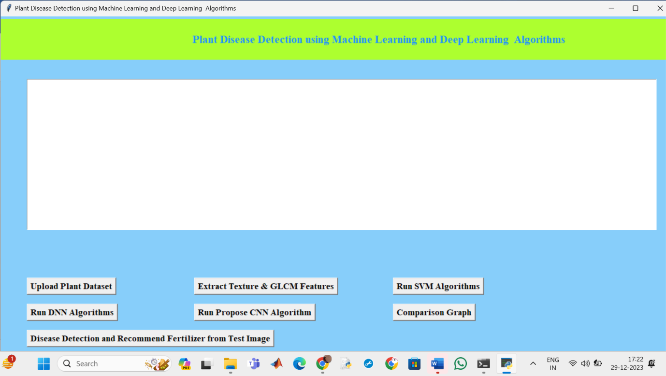
Fig.7.1 Basic GUI

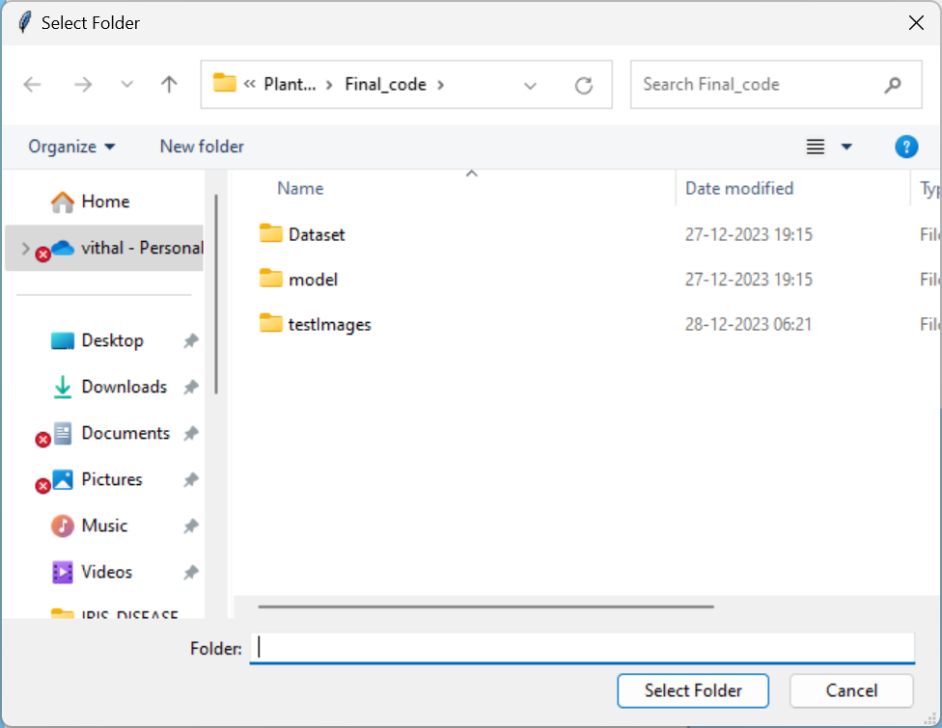
Fig.7.2 Selection of dataset folder

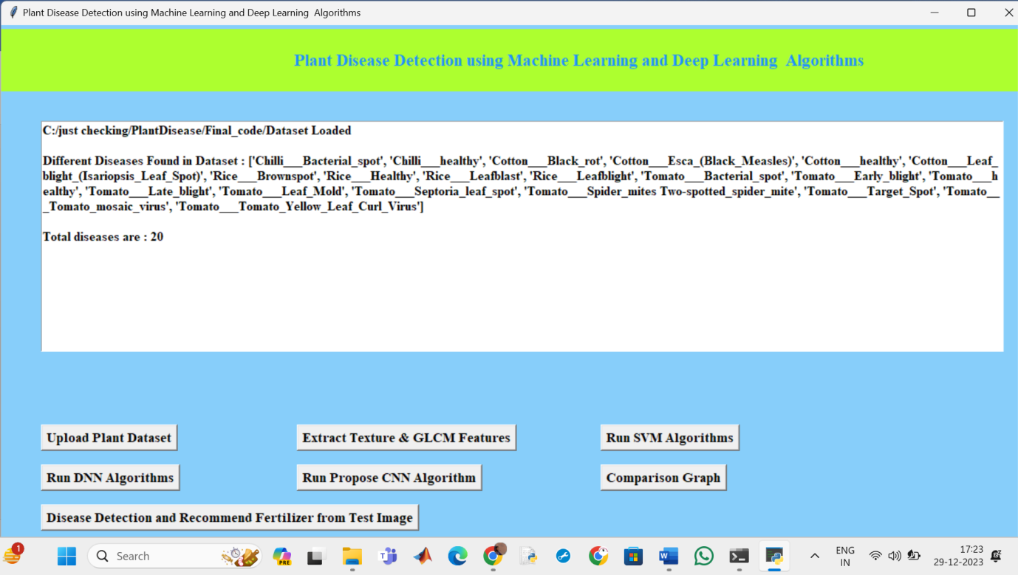
Fig. 7.3After selecting the folder it will display type of plants and diseases

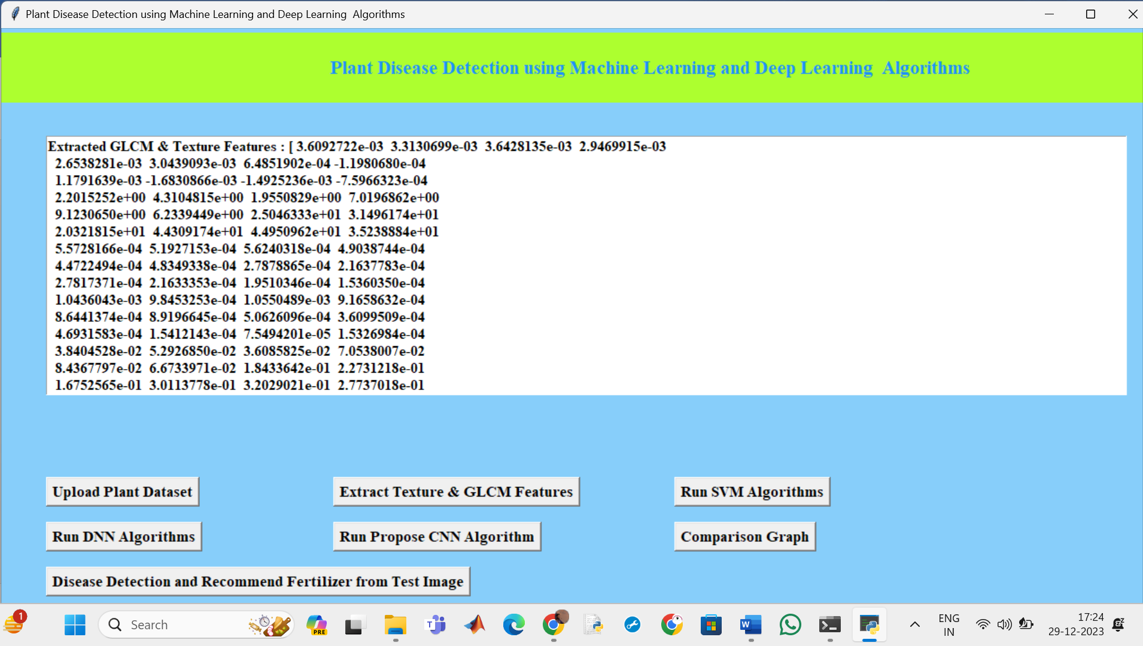
Fig.7.4 Feature Extraction
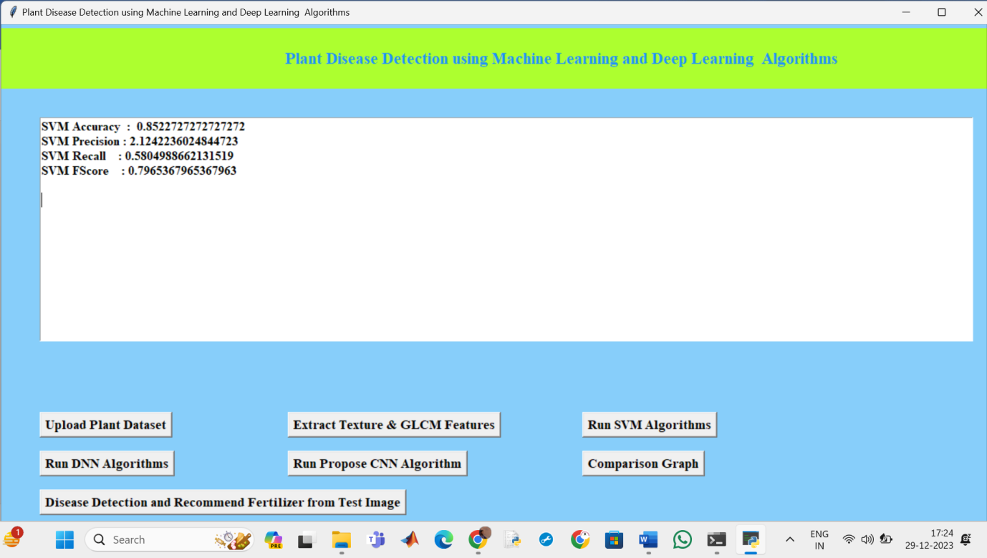
Fig.7.5 SVM classifier results

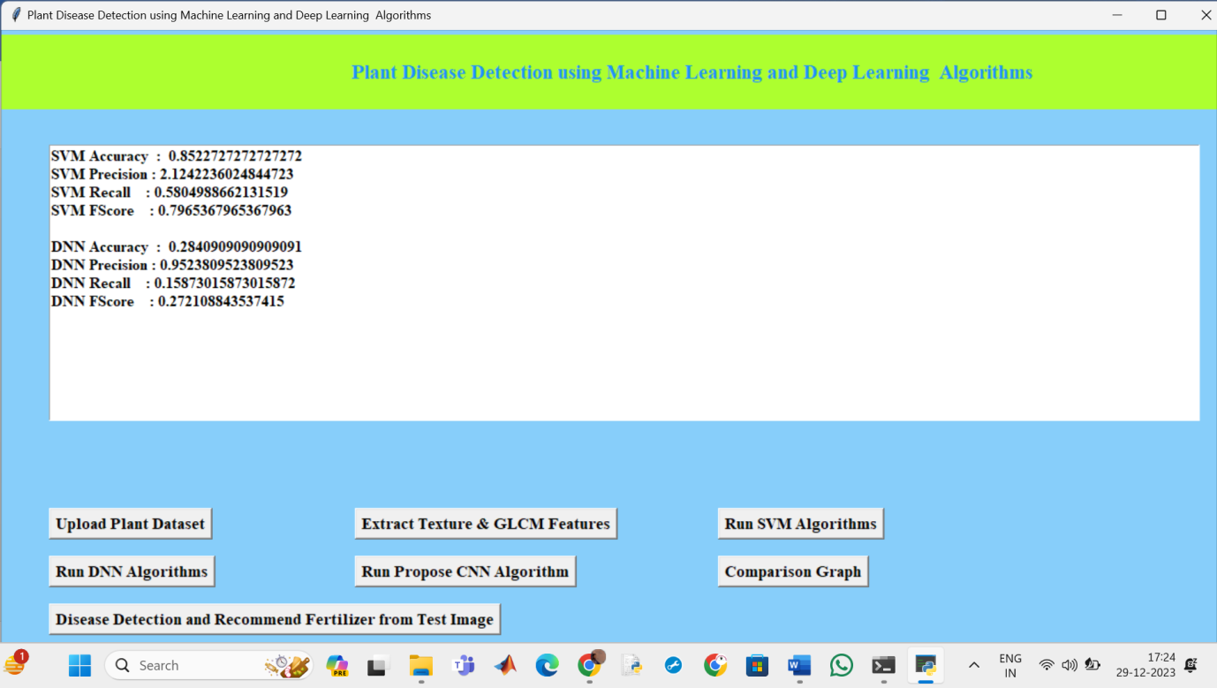
Fig.7.6 DNN classifier Results
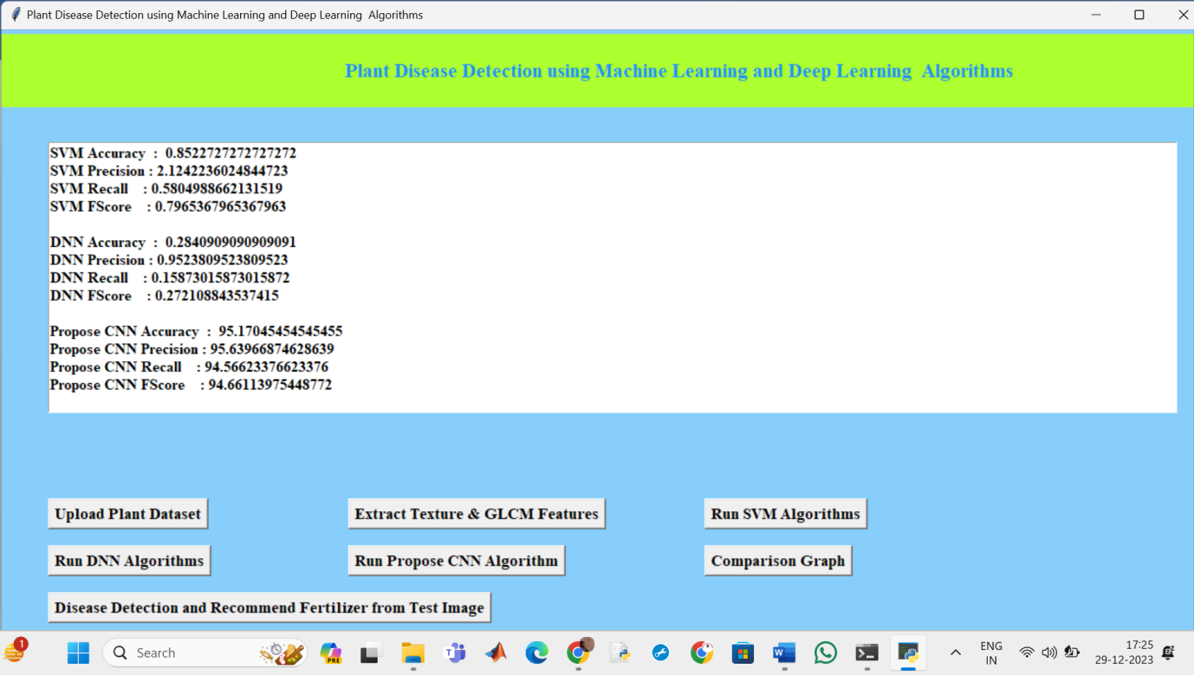
Fig.7.7 CNN classifier results
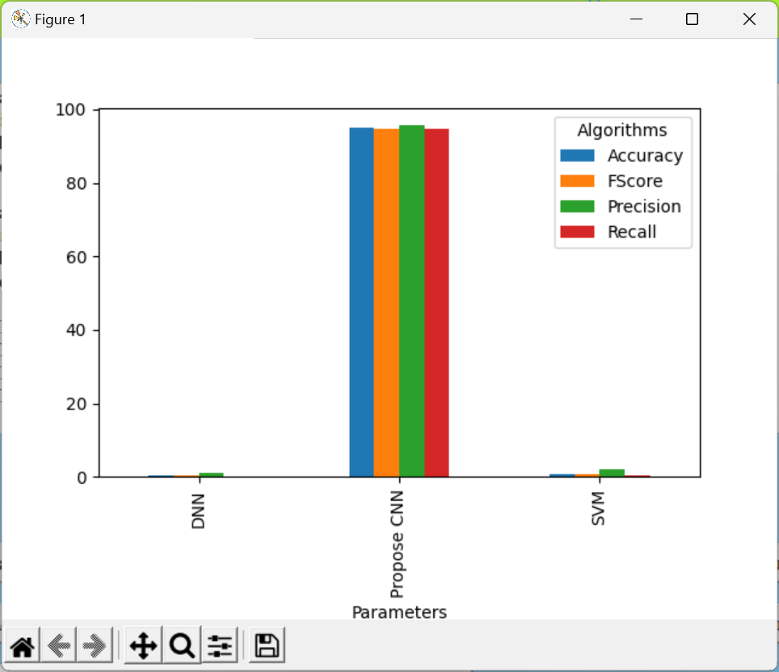
Fig.7.8 Comparision Graph

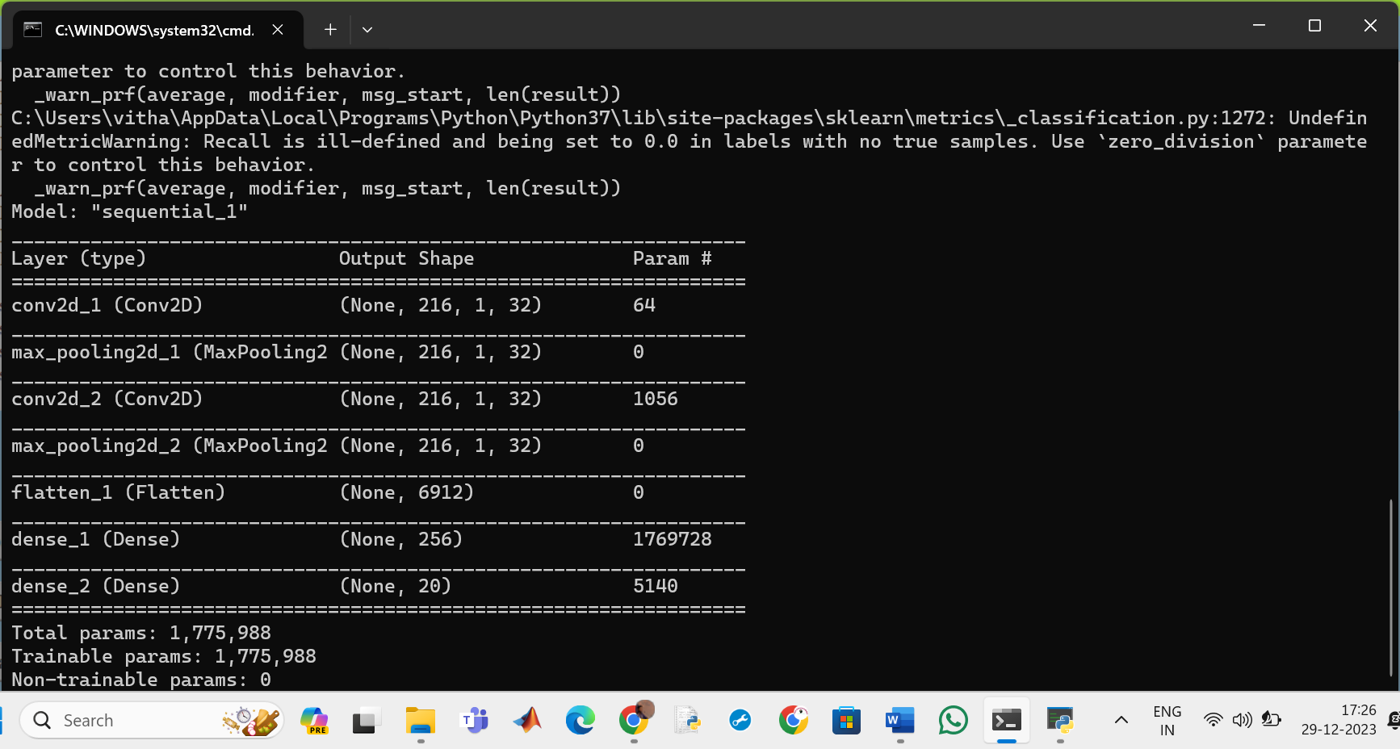
Fig.7.9 CNN structure

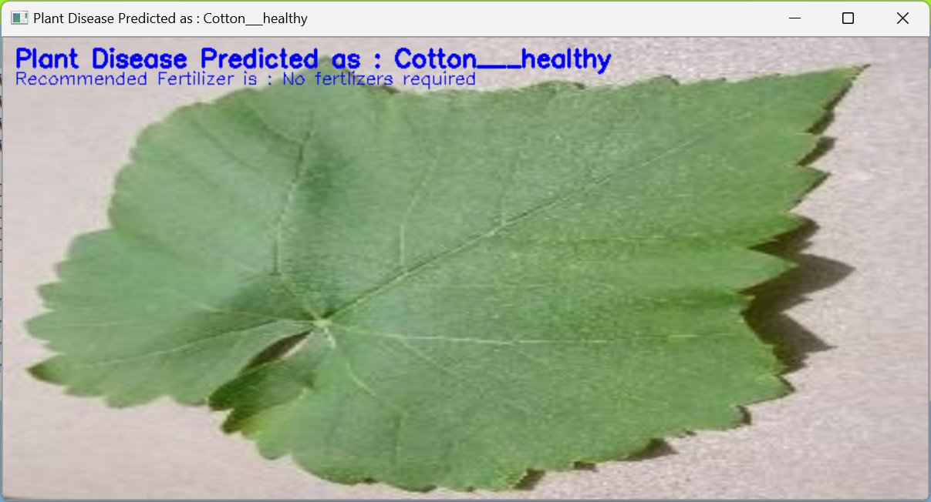
Fig.7.10 Plant regonised as Healthy cotton plant and no fertilizers required

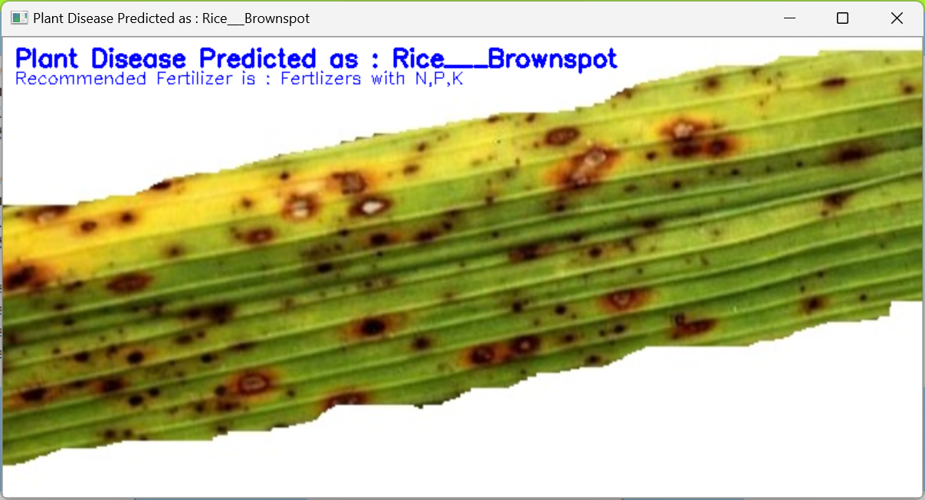
Fig.7.11 Rice brown spot and fertilizer recommended is N,P,K

CHAPTER 8
CONCLUSION
Leaf disease classification using Central Neural Network has been successfully analyzed using image processing method and classified using Neural Network to get the performance of the data. In this paper, for plant leaf disease detection, we are using four plants, such as chillies, cotton, rice, and tomatoes. The image processing method has been applied to 100 samples of leaf and the data based on color and area of unhealthy analysed. The objective to capture and analysis data from leaf images for classify healthy or unhealthy of the leaves of medicine plants was achieved using image processing method. From image processing method, algorithm of adjusted contrast, segmentation and features extraction is used to extract image and to get data. The three of the method are included in image processing method. The experiment results have been done using Central Neural Network. Multi-layer feed forward Neural Network which are multi-layer perceptron and radial basis function RBF are the structures of the network used to class healthy or unhealthy of leaves. In the final experiment, the result shows that the RBF network performs better than MLP network.

REFERENCE
[1] United Nations, Department of Economic and Social Affairs, Population Division (2019). World Population Prospects 2019: Highlights (ST/ESA/SER.A/423).
[2] Savary, Serge, et al. "The global burden of pathogens and pests on major food crops." Nature ecology & evolution 3.3 (2019): 430.
[3] Mohanty, Sharada P., David P. Hughes, and Marcel Salathé. "Using deep learning for image-based plant disease detection." Frontiers in plant science 7 (2016): 1419.
[4] Fujita, E., et al. "A practical plant diagnosis system for field leaf images and feature visualization." International Journal of Engineering & Technology 7.4.11 (2018): 49-54.
[5] Haralick, Robert M., Karthikeyan Shanmugam, and Its' Hak Dinstein. "Textural features for image classification." IEEE Transactions on systems, man, and cybernetics 6 (1973): 610-621.
[6] Cortes, Corinna, and Vladimir Vapnik. "Support-vector networks." Machine learning 20.3 (1995): 273-297.
[7] Cunningham, Padraig, and Sarah Jane Delany. "k-Nearest neighbor classifiers." Multiple Classifier Systems 34.8 (2007): 1- 17.
[8] Haykin, Simon. Neural networks: a comprehensive foundation. Prentice Hall PTR, 1994.
[9] Szegedy, Christian, et al. "Going deeper with convolutions." Proceedings of the IEEE conference on computer vision and pattern recognition. 2015.
[10] Duan, Kai-Bo, and S. Sathiya Keerthi. "Which is the best multiclass SVM method? An empirical study." International workshop on multiple classifier systems. Springer, Berlin, Heidelberg, 2005.
[11] Deng, Jia, et al. "Imagenet: A large-scale hierarchical image database." 2009 IEEE conference on computer vision and pattern recognition. IEEE, 2009.
[12] G. Wang, Y. Sun, and J. Wang, “Automatic image-based plant disease severity estimation using deep learning,” Computational Intelligence and Neuroscience, vol. 2017, Article ID 2917536, 8 pages, 2017.
[13] A. Kamilaris and F. X. Prenafeta-Boldú, “Deep learning in agriculture: a survey,” Computers and Electronics in Agriculture, vol. 147, pp. 70–90, 2018.
[14] K. P. Ferentinos, “Deep learning models for plant disease detection and diagnosis,” Computers and Electronics in Agriculture, vol. 145, pp. 311–318, 2018.
[15] R. I. Hasan, S. M. Yusuf, and L. Alzubaidi, “Review of the state of the art of deep learning for plant diseases: a broad analysis and discussion,” Plants, vol. 9, no. 10, article 1302, 2020.
[16] K. Lin, L. Gong, Y. Huang, C. Liu, and J. Pan, “Deep learning-based segmentation and quantification of cucumber powdery mildew using convolutional neural network,” Frontiers in Plant Science, vol. 10, p. 155, 2019.
[17] J. G. A. Barbedo, “Factors influencing the use of deep learning for plant disease recognition,” Bio systems Engineering, vol. 172, pp. 84–91, 2018.
[18] A. Ramcharan, P. McCloskey, K. Baranowski et al., “A mobile-based deep learning model for cassava disease diagnosis,” Frontiers in Plant Science, vol. 10, p. 272, 2019.
[19] A. Dhakal and S. Shakya, “Image-based plant disease detection with deep learning,” International Journal of Computer Trends and Technology, vol. 61, no. 1, pp. 26–29, 2018.
[20] S. Wallelign, M. Polceanu, and C. Buche, “Soybean plant disease identification using convolutional neural network,” in Proc. Thirty-First International Florida Artificial Intelligence Research Society Conference (FLAIRS-31), pp. 146–151, Melbourne, FL, USA, 2018.
[21] T. Wiesner-Hanks, E. L. Stewart, N. Kaczmar et al., “Image set for deep learning: field images of maize annotated with disease symptoms,” BMC Research Notes, vol. 11, no. 1, p. 440, 2018.
[22] K. Nagpal, D. Foote, Y. Liu et al., “Publisher correction: development and validation of a deep learning algorithm for improving Gleason scoring of prostate cancer,” NPJ Digital Medicine, vol. 2, no. 1, p. 113, 2019.
[23] V. V. Adit, C. V. Rubesh, S. S. Bharathi, G. Santhiya, and R. Anuradha, “A Comparison of Deep Learning Algorithms for Plant Disease Classification,” in Advances in Cybernetics, Cognition, and Machine Learning for Communication Technologies, Lecture Notes in Electrical Engineering, vol. 643, pp. 153–161, Springer, Singapore, 2020.
[24] A. Ramcharan, K. Baranowski, P. McCloskey, B. Ahmed, J. Legg, and D. P. Hughes, “Deep learning for image-based cassava disease detection,” Frontiers in Plant Science, vol. 8, article 1852, 2017.
[25] S. Verma, A. Chug, A. P. Singh, S. Sharma, and P. Rajvanshi, “Deep Learning-Based Mobile Application for Plant Disease Diagnosis: A Proof of Concept With a Case Study on Tomato Plant,” in Applications of Image Processing and Soft Computing Systems in Agriculture, pp. 242–271, IGI Global, 2019.

